**AWS Databases contd**

* Single Region: Single Database with Read Replica  
  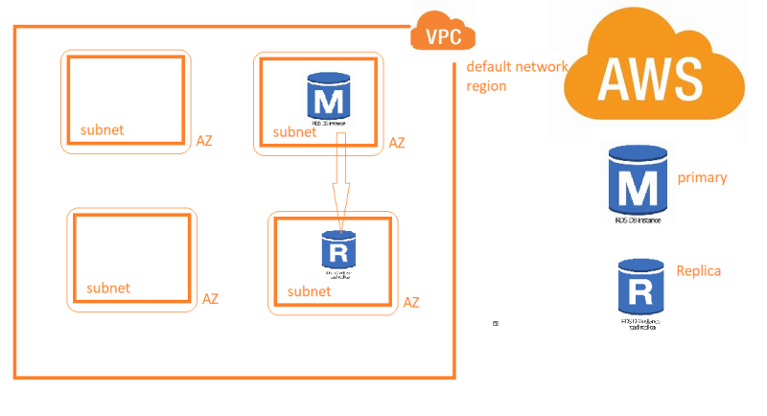
* Multi Region: Single Database with Read Replica in other region  
  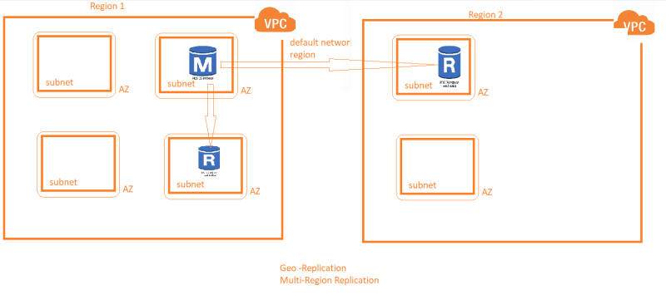
* Multi-AZ RDS deployment  
  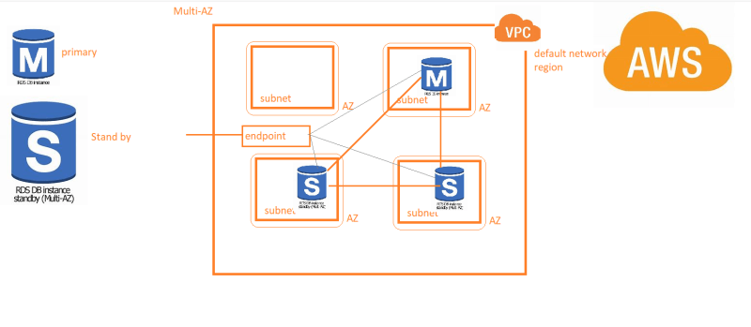
* Multi AZ generally as a Master instance and one or more standby instances
* Multi AZ is generally preferred for production environments  
  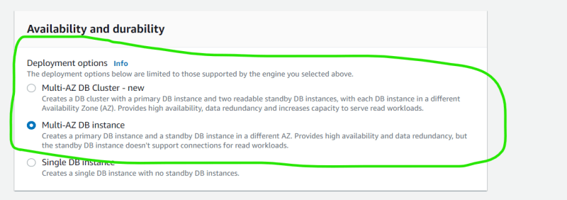
* Create the multiaz db instance as discussed in the class (not free tier eligible)  
  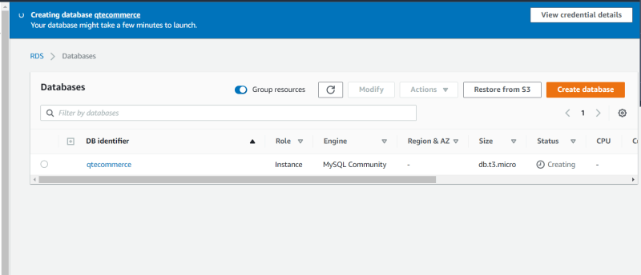
* Lets create an estimate of pricing <https://calculator.aws/#/>
* Single AZ  
  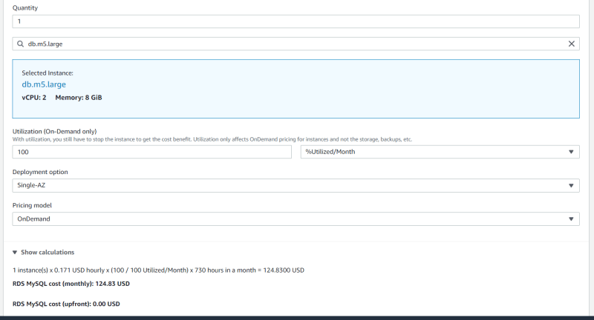
* Multi AZ  
  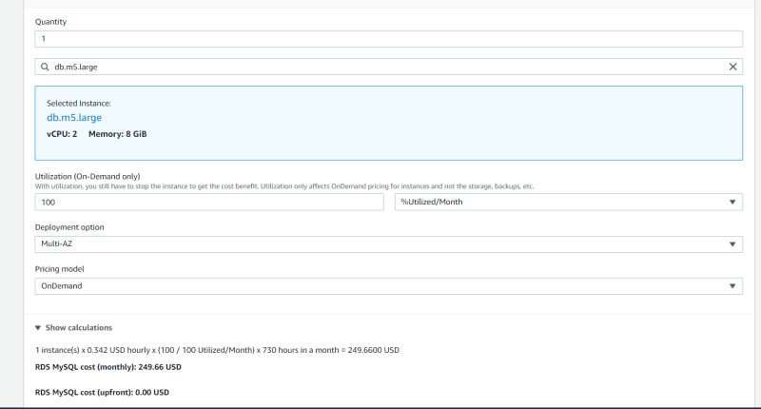
* Reservations: We give a long term commitment to AWS (1 year or 3 years)
  + Payment options are monthly, partial upfront, full upfront (highesht discount)
  + Production databases are generally reserved to save costs
* Next Steps:
  + Understanding Backups
  + Understanding subnet groups, parameter groups etc
  + Understanding Aurora.